**Han Academy Web**

**Software Design Document**

|  |  |  |  |  |
| --- | --- | --- | --- | --- |
| Software Name: | Han Academy Web | Version #: | | 3 |
| Author: | Amanda Cobb | | | |
| Date: | October 12, 2015 | | | |
| Revision History: | | | Date: | |
| Initial write up | | | 10/8/2015 | |
| Revision 1 | | | 10/10/15 | |
| Revision 2 | | | 10/12/15 | |

**Introduction 3**

Purpose: 3

Stakeholder: 3

Social and Economic Benifits: 3

**Overall Description 4**

Architecture 4

Available Sources 5

**Functional Requirements 6**

Add Courses 6

Make course inviable 6

Java Code 6

Add Activities 6

*Add Resourcess 6*

*Add URL 6*

*Add an Assignment 6*

*Add Quizzes/ Tests 6*

*Add Chat 6*

Modify Tasks 6

*Delete Task 6*

*Modify quiz 6*

*Modify Hyperlink 6*

View/grade submitted homework 6

Monitor the student’s progress 6

Provide answers to a Q/A forum 7

**Interface Requirements 9**

Navagation of the Instructor’s view 9

Screen Descriptions 9

*Dashboard and Site Home 9*

*Add Course 11*

Add Task Submenu 11

**Add Resource** 11

**Add URL** 12

**Add an Assignment** 12

**Add Quiz** 12

**Add Chat** 12

Monitor student Progress 18

View/Grade submitted homework 18

**Data Management 21**

Database changes 21

Entity Relationship Data Dictionary Changes 21

**Non-Functional / Operational Requirements 23**

Security 23

Availability 23

Reliability 23

Recoverability 23

**Appendices 24**

Requirement Engineering Methodology 24

Meeting Minutes 24

*Meeting #1 24*

*Meeting #2 26*

*Meeting #3 29*

# Introduction

## Purpose:

This application is to improve an existing Moodle, to better serve parent, student, and teacher. It will make all information posted accesable from any PC with internet connection. The application will mainly be focusing on K-12 grades. The application will enable students to learn better and teachers be more efficient. This application also allows communcation to occur between teacher and parent or teacher and student.

Moodle is used to help design their own themes and make it special for Han Acadmey. This way their no useless iteam visable that another organization might have used.

## Stakeholder:

There are 3 sets of stakeholders for this product: Students, Teachers and Administrators. The main stakeholder affected by the changes described in this document are the teachers.

## Social and Economic Benifits:

The current teachers interface and functions are very basic and not user friendly. These changes will make the teacher’s interface more robust and easier to use.

# Overall Description

## Architecture

Hosted by: AWS

SQL Database

File Server

**Presentation**

Logic written in C#

**Web Site**

GUI written in .net

AWS provides security settings to act as a fire wall

AWS provides user Authentication

**INTERNET**

**USERS**

**USERS**

**USERS**

**USERS**

**USERS**

**USERS**

**USERS**

Figure 1

The new changes described in this document will be added to the current HanAcademyWeb.org architecture.

The current architecture is hosted by AWS (Amazon Web Services). This site offers a complete set of infrastructure and application services that allow us to run everything in the cloud.

We use AWS’s tools to provide us with security and user login authentication. This is a much cheaper alternative to having to write and maintain code for these purposes.

The Web code is written in .net. This is placed on the AWS server for easy access for the user.

The business logic that is behind the web code is written in C++. This code also interfaces with the database and file server provided by AWS. All the data for our application is currently stored into an AWS’s SQL Database.

All users can access our application via the internet.

## Available Sources

* The Han Academy Web application is available from any PC that has internet access.
* The software will be deployed to the Cloud (via AWS server) and the new version will be accessed by the teachers the next time they log in.
* There will be no additional hardware or set ups needed for this change. We will be leveraging the basic set up is already in place with the current Han Academy Web application.
* The current Han Academy Web application is written in C sharp. All extensions of this application should be written in the same language for maintainability.
* Required Development Tools
* Security would stay consistent with the security already in place for this application on AWS.

# Functional Requirements

The course web application (CW) supports four different roles: Administrator, Teacher, Student, and Parent.

The current version of Han Academy is still under construction but it being used as is. The purpose of these changes is to improve a working site. The administrator needs the following functions:

## Add a new Course

This allows the courses offered to show for all users so the students can sign up for the classes or the teachers can add content to their classes.

## Turning a Course invisible

This means the course will not be offered and shouldn’t be visible to the student users. This way the students don’t sign up for a class not being offered but it still there for the next time it is offered.

## Java Code

When the Computer Teacher assigns some java code then the site will automatically check to see if the code is working correctly.

#### Case 1

The code is working correctly, so the student passes.

#### Case 2

The code is working incorrectly because of a Syntax Error, so the student fails.

#### Case 3

The code is working incorrectly because the code is wrong, so the student fails.

## Adding a Resource or Activity

#### Adding a Resource

This allows the teacher user to post content on to their desired course. Such as posting a chapter PowerPoint for the Students to follow along and study.

#### Adding a URL

This can give the students another resource that the teacher approves of. Having a website to go to can be very helpful when it’s useful for the student. The URL can be just for extra learning, a reading assignment, or even a tool for a paper.

#### Adding an Assignment

Posting an assignment online can help the teacher collect all homework with saving paper for the environment and in case the school is closed or the teacher is absent. An assignment online can also tell the teacher when the student turned in the assignment any time of day.

#### Adding Quizzes and Tests

Posting a Quizzes and Tests online can save paper and also taken at home. If the school is closed or the teacher is absent, then the teacher can still have the assigned Quiz or Test. It will help keep the course on schedule. The teacher will be able to modify the quizzes and tests such as changing the questions and answers or deleting certain questions.

#### Adding Chat

Chat can be a great way for students to interact over the internet about anything (mainly the course, preferably). The teacher can also chat with the students. The chat is a great for a student that is stuck to post his or her question and hopefully get the answer that will help them for that topic.

## View/grade submitted homework

The students will be able to submit their homework in their user view. The teacher will need to be able to open the student’s homework and add the points earned to their total for the class.

## Monitor the student’s progress

The instructor will be able to view the student’s progress. This needs to be available be viewed by a single student or the whole class at once.

## Provide answers to a Q/A forum

This will be a new forum for the whole course where a student can ask a question and the instructor will answer the questions. These questions/answers will be left in the forum to be used as a resource for other students. It’s much like the chat but Chat is for the different topic not the whole course.

# Interface Requirements

## Navigation of the Overall view

Login

Dashboard Screen

Site Home

Add Courses

Question/ Answer form

Monitor Student progress

Add Activities

Modify Activities

Modify Activities Menu

Question/ Answer form Screen

Monitor progress Screen

Add Activities Menu (Figure 8)

Delete Activity

Add Resource

View/Grade submitted homework

Modify quiz

Add quiz

Modify Hyperlink

Add URL

Figure

## Screen Descriptions

### Dashboard Screen

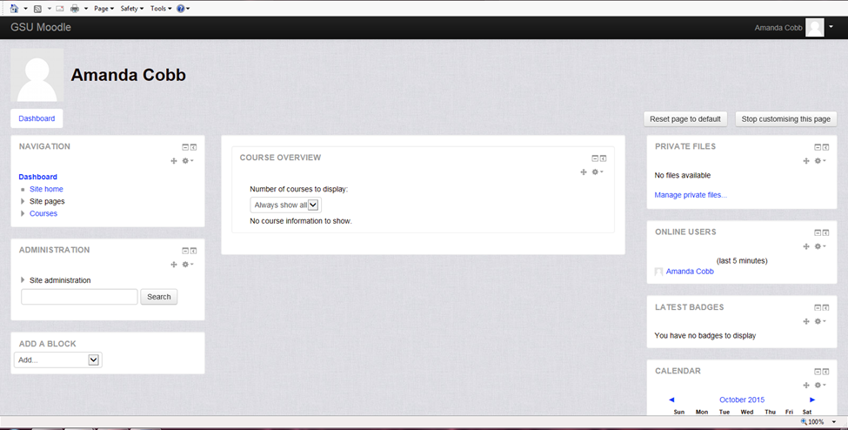

The Dashboard Screen is for the individual that logged in to the site. It shows the courses that are being taken along with the calendar. From here the user can go to the Site Home.

### Site Home

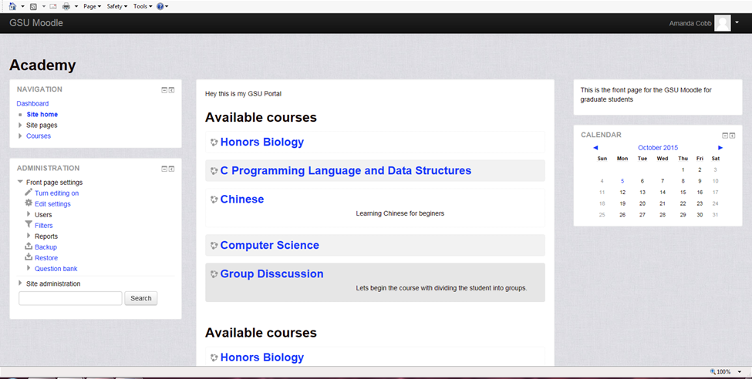

The Site Home page shows all the courses available for the semester, the course categories and a Course search box.

#### Add Courses

When the administrative user adds a new course then the picture below will appear after clicking “Add new Course” button. After typing in all the necessary content and click the “Add” button then the course will be added to the rest of the Courses in the site.

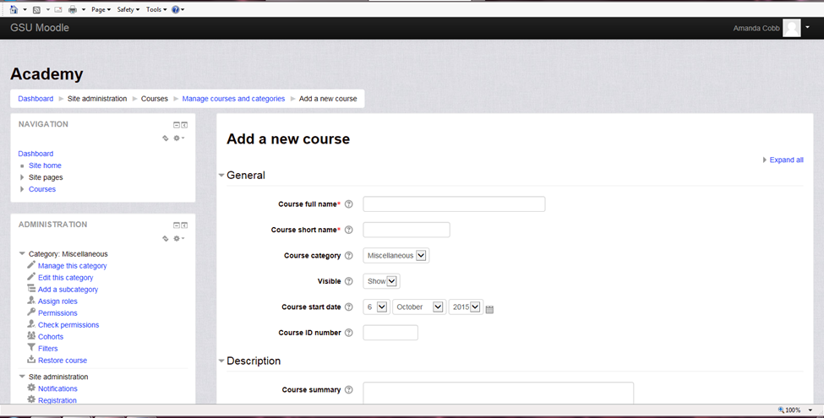

#### Add Activities

When the teacher user clicks on the “Add Activities” button in the Course, the screen shown here will appear in the center of the screen. The teacher will then pick what activity to add. Such activities as Resource, URL, Quiz, and Chat.

#### 

#### Add Resources

This is a new screen that will appear when the teacher user clicks “Add Resource” button. The teacher user must then enter the necessary details for the resource.

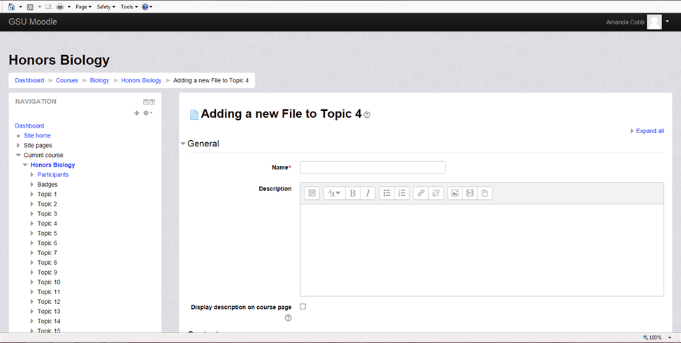

Once that is completed the teacher must then add the content to the resource by clicking within the box or dragging and dropping the content. If you the teacher user clicks’ with in the box then this screen should appear.

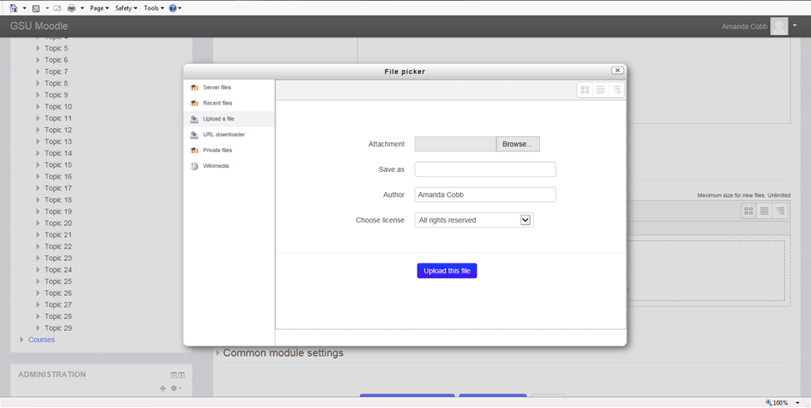 After adding the content to the Resource then the teacher user can click the “Save and Display” button.

#### Adding URL

The teacher user can click the URL link under the Resource Section and click the ‘Add’ button. The picture below is the screen that will appear. 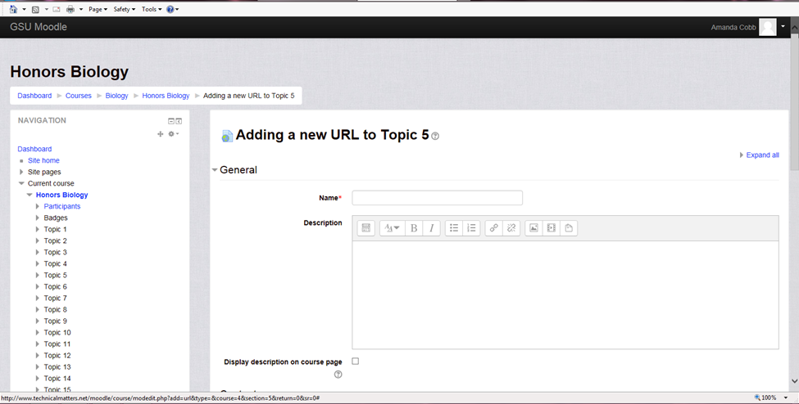

Enter all the details that you as the teacher user would like. The URL can be copied and pasted in the textbox or click the ‘Choose Link’ button. The screen below is what will appear after the ‘save and display’ button is clicked.

#### Add an Assignment

To add an assignment, click the assignment link. Then click the add button. The picture below should be the screen the user gets.

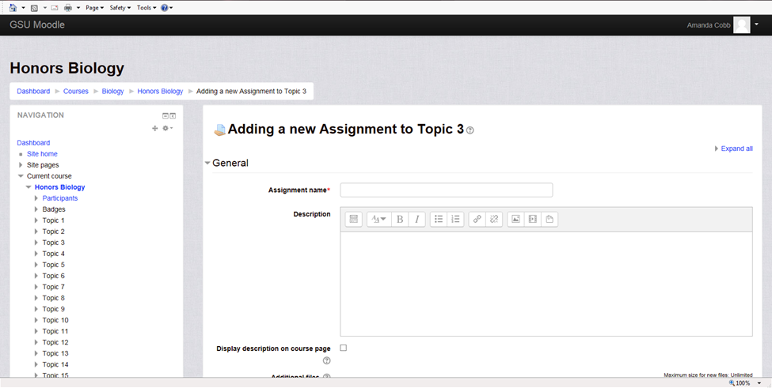

Enter all the detail you as the user would like, then press the ‘save and display’ button. The screen you come to is the submissions for the assignment and the number participants.

#### Add a Quiz or Test

To add a Quiz, click the Quiz link and then the ‘Add’ button. The picture below shows the screen that will appear.

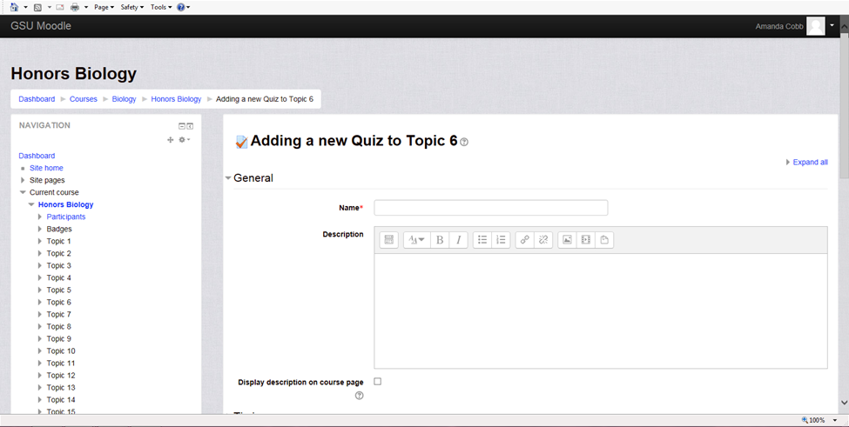

Enter the details you as the teacher user would like, such as the name of the Quiz. To edit the quiz, click the button ‘Edit Quiz’. Click the ‘Add’ link to get choice between ‘new question’, ‘from the question bank’, and ‘random question’. Click the one you as the teacher user would like. The picture below is what appears when the ‘new question’ link is clicked.

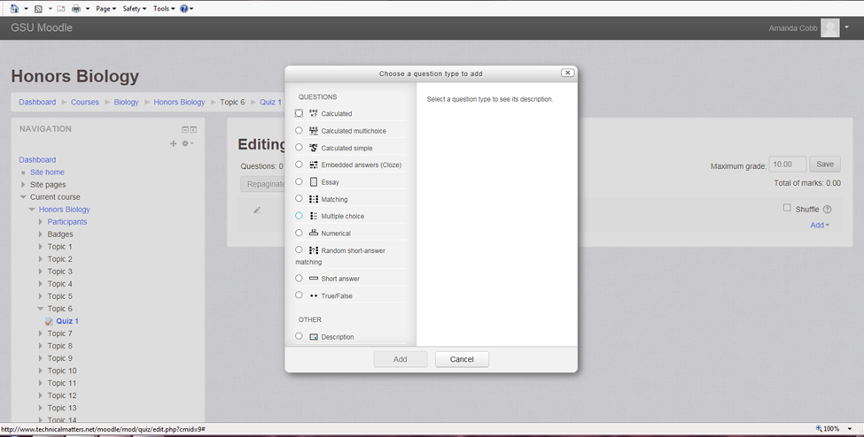

Click the type question it will be, such as ‘matching’, ‘multiple choice’, ‘True/False’, etc. Then click the ‘add’ button. Enter the question and the different answers. Make sure the correct answer the student can get the credit for selecting it. The picture below is the screen that will show question has been added.

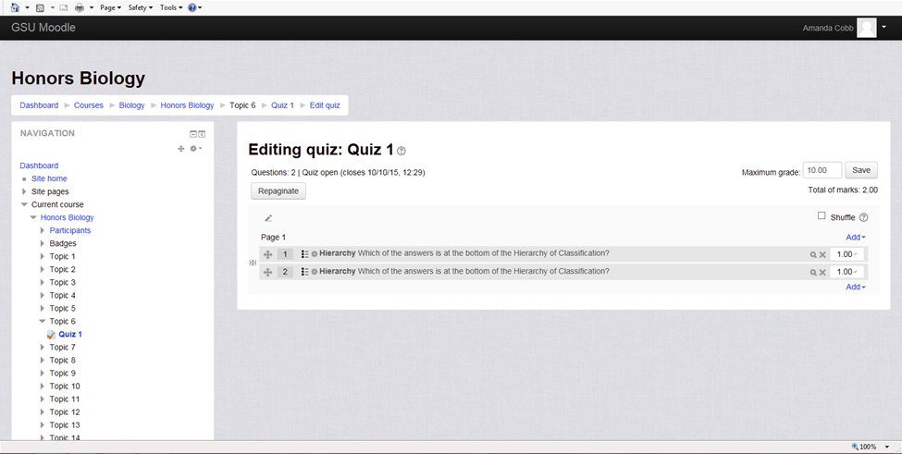

To delete a question click the X and picture below is what the screen will look like.

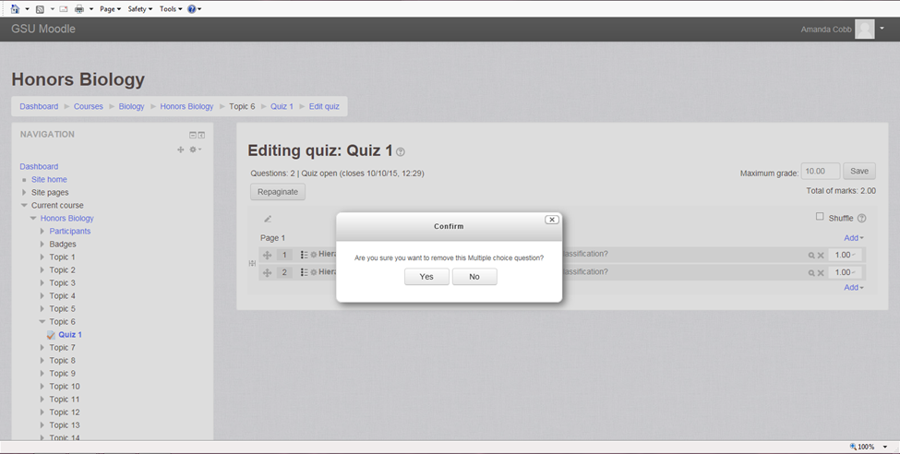

Click ‘yes’ and the screen will look similar to the picture below with the missing question.

##### 

#### Add Chat

Chat is a lot like a discussion board for the users. Click the Chat link then the ‘Add’ button.

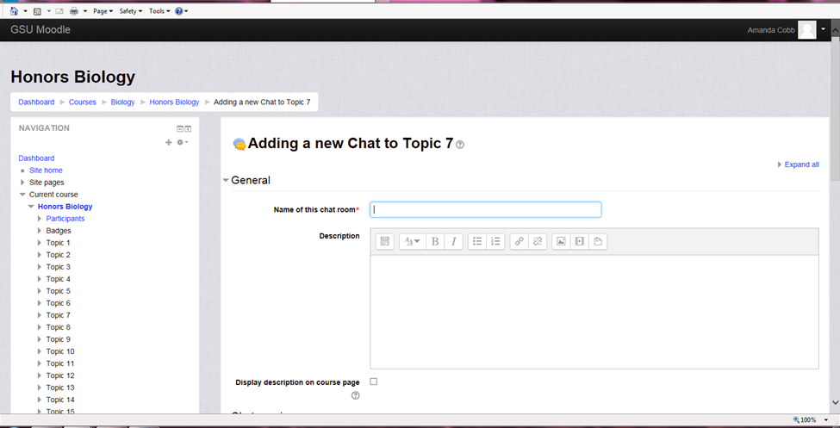

Enter the details you as teacher would like. Such as the name of the chatroom or who view the past messages. If the ‘Click here to enter the chat now’ link is clicked the picture below shows the screen.

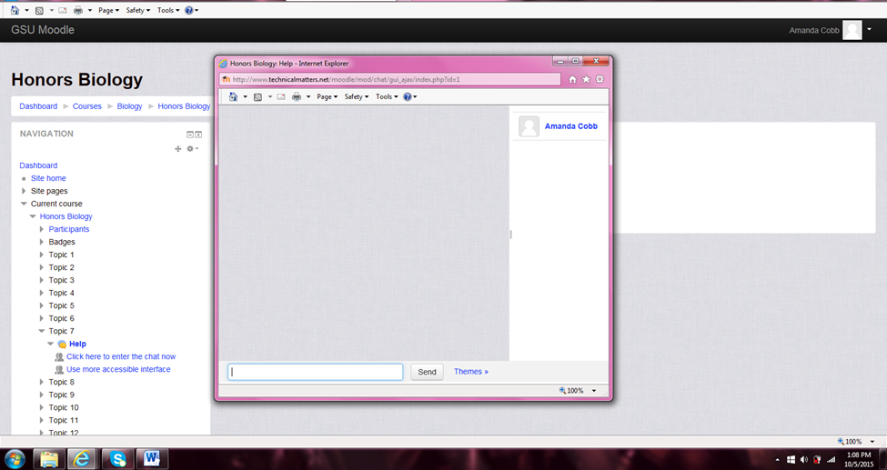

## Monitor student Progress

If a teacher user chooses to monitor students’ progress, the user must go to the Course desired then under the Administration either click Reports to see the activity logs and course participation or click the Grades to see all students’ grades or individual.

When the Activity logs are clicked it will show the teacher who is actually viewing the course online and what they were doing.

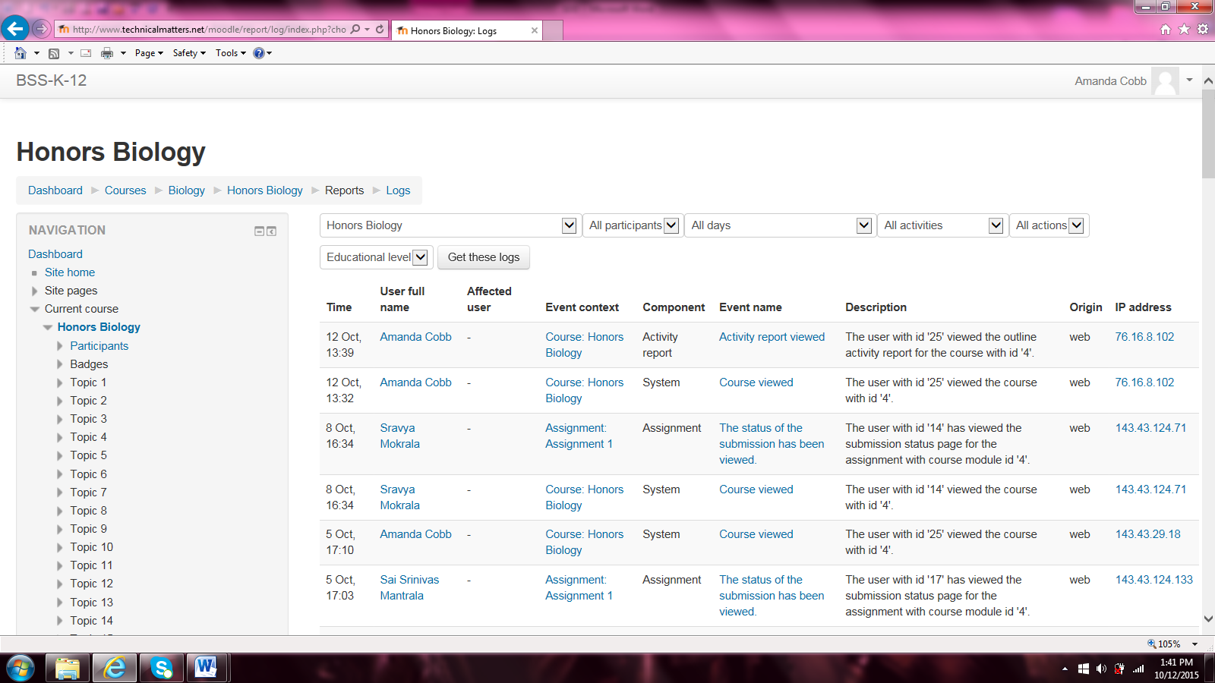

When course participation is clicked it will show the teacher who is actually doing their work. All the teacher user has to do is pick what Activity you want to search by.

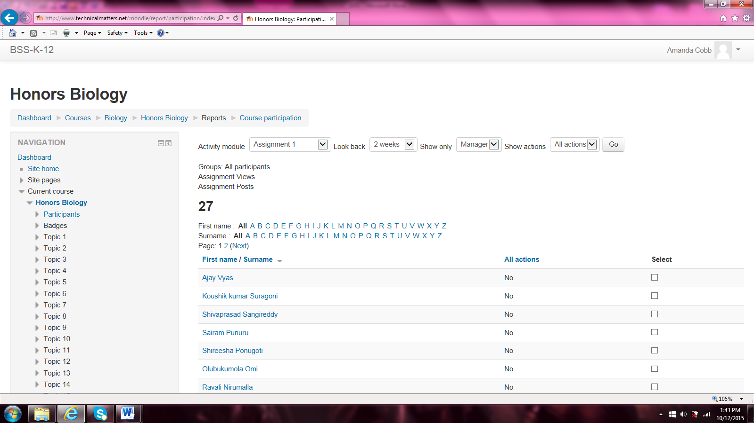

When the Grades is clicked the teacher can view the grades for the whole class or an individual.

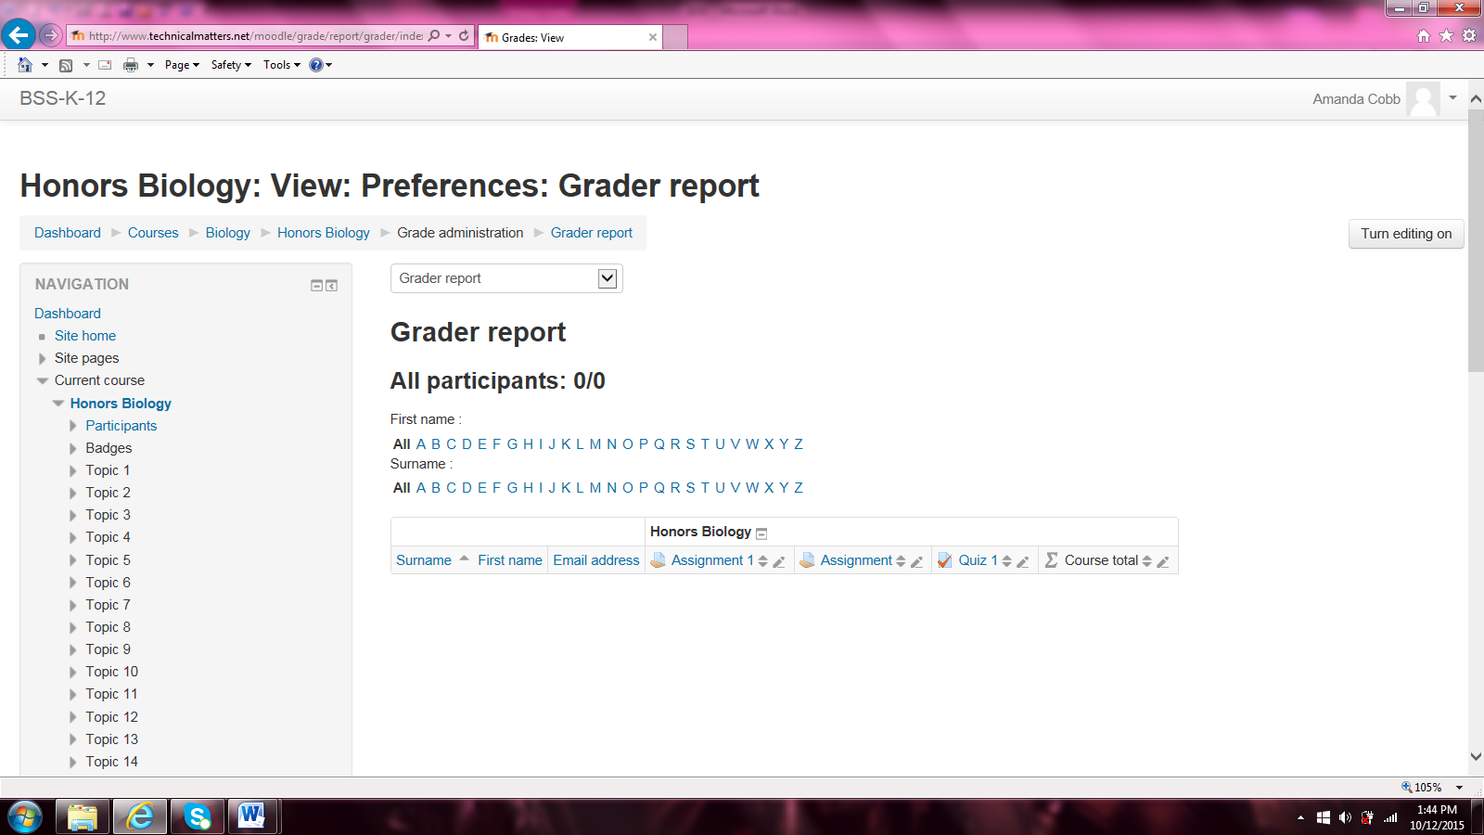

# Data Management

All courses, units, items in the units will be stored in a database. They will remain in the database for 5 years. After which time they will be backed up and stored in a warehouse for record keeping purposes.

Database changes

In order to add the subject and level to the navigation bar, we will need to create two new tables: Subjects & Levels. These tables will contain a list of available subject and available levels. The Administrator’s screen will need to have these fields added to the screen that they enter the course offerings. The new fields on that screen will be drop downs populated from the two new tables.

We will also need to add an additional two more tables to hold the questions and answers for the forum: ForumQuestions & ForumAnswers.

Entity Relationship Data Dictionary Changes

The following are the changes to the ERD for the new Levels & Subject tables. All items in red are new.

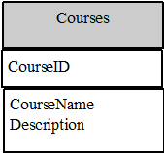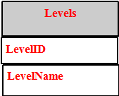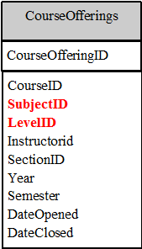

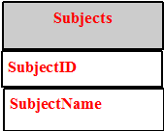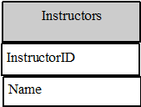

The following are the changes to the ERD for the new ForumQuestions & ForumAnswers tables. All items in red are new.

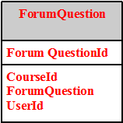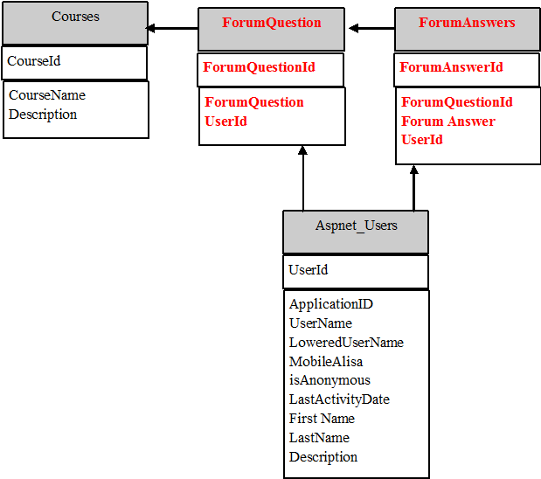

# Non-Functional / Operational Requirements

Security - There is already security in place for this application. All changes made here are to conform to those same standards.

Availability - The system should be available 24/7. If maintenance is needed, it should be done on Saturday mornings from 1:00am - 4:00am.

Reliability -The system needs to be reliable for the students and the instructors to complete their work in a timely fashion.

Recoverability - If the web application fails, a user can re-login and all data will reappear as it is being stored on the database.

# Appendices

## Requirement Engineering Methodology

We will be using an Agile Methodology to complete this project.

## Meeting Minutes

### Meeting #1

Meeting Date: 8/31//15

Meeting Place: GSU

Meeting Attendees: Instructor-Clare Tang & Students

Meeting Minutes: Introduction to Moodle and SRD

Q: What’s the Purpose?

A: To better serve parent, student, and teacher. To help the student learn better. To help the teacher be efficient.

Customer Meeting

Using Moodle. Non-profit organization.

Client: Focus on K-12 grades. I heard that it’s a great, open source. My colleague uses it; I want to use it for my organization.

Client: Did you study Moodle?

Me: Yes

Client: Can you tell me more?

Me: It’s an open source platform for producing modular internet-based courses.

Client: Is there a demo?

Me: Yes

Client: Is it geared towards K-12?

Me: No

Client: Do they have the showcase for the K-12?

Me: No

Client: I’m not sure where to make the account.

Me: Create an account at the home page.

_____________________________________________________________________________________

Client: On the homepage I don’t want the contact info for the teacher but for the school itself.

Client: Clicking on the course, I want it to show a brief description of the course. When clicked you can either enroll or talk to somebody at the school.

Client: After they enroll, they must give detailed information (contact). If there are more than 30 enrolled already, then create a waiting list for the extra enrolling students.

Client: The homepage should be about the school and Click here for enrolling. Must be dynamic. Must be able to have some news (Enrollment time, Conferences, Stay heathy). Any announcements too.

_____________________________________________________________________________________

I don’t like Blackboard (wish list)

Professor: Their enrollment is messed up. If you register late I have to add the student. If a student drops the class then I have to drop them. The enrollment and the student are not in sync.

Professor: its old fashioned look. Too many links to get confused on. It’s not organized at all.

Professor: I can create the quiz, even though it is tedice. It’s linked to the grade book, which is great.

Professor: The course Messages needs be linked to my e-mail. It doesn’t make sense at all.

Like for Students:

Student: The notifications from the grades.

Student: Archive the older classes (in Fall Semester now, archive Summer Semester).

Don’t Like for Student:

Student: Don’t like the look.

Student: When I log in I want to see the e-mail from the professor.

Student: The calendar is a useless feature. Unless everything got uploaded automatically.

_____________________________________________________________________________________

Student: What do you want to do?

Client: I want the parents to enroll in this course. I want the teachers to be able to post their course loads and communicate with students. I want the students to be able to submit and communicate with teacher.

Student: Do you want to post grades?

Client: Yes, and quizzes and tests to be given on the computer.

Student: What are your must haves?

Client: The parents can see the class list. They can click on the course to enroll, give contact info. The teacher must be able to post the content. The student must be able to view the content posted by the teacher. The parents must be able to view the students work.

Student: What about hardware?

Client:

Student: What about Discussion Board?

Client: Maybe. For the students at least.

_______________________________________________________________________

Non-Functional Requirements

* No guests can log-in.
* The number of students.

Where do Requirements come from?

* Client
* Stakeholder(s)—Moodle
* Intended Audience—student(s) in class

### Meeting #2

Meeting Date: 9/14/15

Meeting Place: GSU

Meeting Attendees: Instructor-Clare Tang & Students

Meeting Minutes: Brainstorming possible Improvements and Requirements

Professor: We are working on the project all together. One of the requirements is choose the model for Software Requirement. Usually it is a mix of all of them.

**Professor: Must Have--Is there also a way to tell if a java code is compiled correctly? Can you submit the source code then it some can compile give the output back? (Like ‘Practice It’)

Student(s): Went to ‘Practice It’ and tried it out. (Possibly made account or had a current one)

Professor: Wants to see progress for Requirements doc.

Test Case 1

Public class Hello {

Public Static void main (String[] args) {

System.out.print(“Hello”);

}

}

Press Submit Button

Expected Output Pass/Fail

Hello Hello Pass

Test Case 2

Public class Hello {

Public Static void main (String[] args) {

System.out.print(“Hello”)

}

}

Press Submit Button

Syntax Error

Test Case 3

Public class Hello {

Public Static void main (String[] args) {

System.out.print(“Helo”);

}

}

Press Submit Button

Expected Output Pass/Fail

Hello Helo Fail

Waterfall Model—by Midterm give up to the design doc. Is a sequential design process, used in software development processes, in which progress is seen as flowing steadily downwards (like a waterfall) through the phases of conception, initiation, analysis, design, construction, testing, production/implementation and maintenance.

Spiral Model—by Midterm give small portions of everything. Is a risk-driven process model generator for software projects. Based on the unique risk patterns of a given project, the spiral model guides a team to adopt elements of one or more process models, such as incremental, waterfall, or evolutionary prototyping.

Evolutionary Model—

Agile Model—is a methodology for modeling and documenting software systems based on best practices. It is a collection of values and principles that can be applied on an (agile) software development project.

### Meeting #3

Meeting Date: 9/21/15

Meeting Place: GSU

Meeting Attendees: Instructor-Clare Tang & Students

Meeting Minutes: Went through current site to find what liked

Likes:

* Admin(Manager) add a course

1. Under courses

2. Manage courses

3. Create new category

4. Make category

* Being able to move the courses where I want (Like grouping all Sciences together)
* Being able to hide or visible certain courses
* Honors system is for Courses not individuals
* Start Date:

1. Shows a calendar to pick the date

* Show activity reports
* Maximum upload size
* Allow guest access (no)

Need: the ‘enrol users’ button needs be to change to ‘enroll users’

* Turn courses invisible when not offered.
* Format—topic is the most useful
* Have a manger be able to add courses not teacher.

Go to Site Admin

1. Go to front page

2. Got to front page settings

3. Display: List of Courses

4. Display: Course Search Box

5. Maximum Courses (200)

6. Default homepage: student

7. Save changes

Go to Appearance

1. Go to themes

2. Go to Theme Settings

3. Enable device detection

4. Go to Clean

5. Add a logo—will have to play around with the size

6. Custom CSS

7. Add Footnote—need to change Moodle Docs

8. Save changes

9. Go to Manage Tabs

10. Add official tags

11. With tag selected, click down arrow, click delete and then ok

Need: full screen video (right now it doesn’t work).